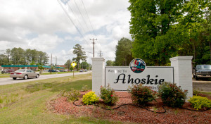
Town of Ahoskie, NC
2022 Comprehensive Plan | Draft | April 2022
Table of Contents
Acknowledgements 3
Existing Conditions 5
Demographics 6
Population decline 6
Age 7
Race and Ethnicity 8
Education 8
Income 9
Land Use and Environment 9
Economic Development 10
Housing 11
Community Engagement 12
Goals and Policies 13
Future Land Use 14
Place Types 14
Future Land Use Map 16
Implementation Strategies 17
Plan Adoption and Tracking 21

Acknowledgements
Many community members and outside volunteers helped to create this comprehensive plan. We want to extend a thank you to all who donated their stories, expertise, and time in developing the 2022 Ahoskie Comprehensive Plan.

Ahoskie Town Staff
Jennifer Bracy
Kerry McDuffie
Patricia Bradley
Susan Doughtie
Angela Fitzhugh

ahoskie Planning Board
X
X
X

UNC-Chapel Hill Department of City and Regional Planning
Julia Maron
Eve Lettau
Jacob Newton
Deanie Anyangwe
Lauren Jensen
Kayla Taylor
Dick Hails

Others
John Morck
Residents and community members in Ahoskie

Executive Summary

The purpose of the Ahoskie Comprehensive plan is to help chart a new course for the community over the next 20 years. This plan seeks to identify Ahoskie’s assets, opportunities, and weaknesses, to create inclusive growth that will serve the needs of desires of those who live and work nearby.
The comprehensive planning process is required by the North Carolina General Assembly. Chapter 160D of the NC General Statutes requires all communities to create a comprehensive plan to exercise zoning authority. This plan was created in response to that requirement.
Based on community feedback and engagement, the plan contains five key sections. These sections contain an analysis of trends, community feedback, goals, future land use, and implementation strategies. Together these sections aim to help determine how the community seeks to grow and change in the future.
Except where otherwise noted, data were collected from three primary sources:
- Personal correspondence with four town staff and six to eight residents,
- Official local government documents and data sources at the municipal and county level, including plans, ordinances, and GIS data, and
- Census Bureau quantitative data, primarily from the American Community Survey 2020 5-year estimates, 2020 Census data, or otherwise from the 2010 Census data where needed.

Graphic 1: The Comprehensive Planning Process

Existing Conditions
Ahoskie, North Carolina is known locally as “the only one,” with a unique name to match the community. situated in Hertford County, the 4,695 resident town is the largest in the county, which has a total population of 24,012 residents.
Figure 1: ahoskie is located in Hertford County, in the NORTHEAST portion of North Carolina.

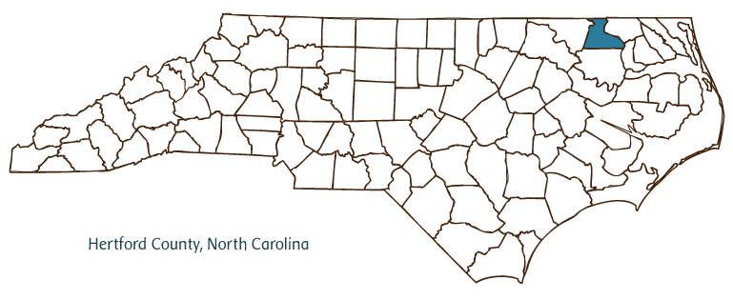
With an area of 4.32 square miles, Ahoskie continues to serve as a hub for industry and connection between eastern North Carolina and Norfolk and southern Virginia. Categorized as economically distressed¹, the town has seen a steady decline in population and a lack of economic development. This section provides an overview of the community’s demographic trends. Some key findings are as follows:
SOURCE: NC One Map, 2022.

- Ahoskie’s population is middle aged and has been decreasing over time.
- Living in Ahoskie is significantly more affordable than in other portions of North Carolina.
- Ahoskie has been an important hub for moving goods from eastern North Carolina to southern Virginia.
The findings and information contained in this section help paint a picture of where Ahoskie has been and is predicted to go in the future. These trends directly inform the goals and policies in this report. Chapter 160D of the NC General Statutes requires comprehensive plans review past, present, and projected trends in the planning process. These trends directly inform the future goals and policies in this report.

Demographics
This section details characteristics of the population in Ahoskie. It contains trends about population growth, age, sex, and education. Demographic trends help show who lives and works in the community to create goals that serve Ahoskie’s population.

Population decline
Ahoskie has seen a marginal decline in population since 2010 (Figure 2). There has been a negative 3% change in population in the town, as well as Hertford County, between 2015 and 2020 compared to an increase of 5% in North Carolina overall (Table 1).
FIGURE 2: SINCE 2010, AHOSKIE’S POPULATION HAS BEEN DECREASING.

Source: American COmmunity Survey 5 Year population Estimates, accessed through SocialExplorer.com

Rural communities across North Carolina have experienced a declining population, where more urbanized areas have attracted residents and grown in population. Projections from the North Carolina State Office of Budget and Management put total population for Hertford County at 17,191¹. The resulting decrease is likely due to a decrease in birth rate and emigration of residents moving elsewhere.

TABLE 1: COMPARED TO HERTFORD COUNTY, AHOSKIE’S POPULATION IS DECLINING AT THE SAME RATE.
 | 2015 | 2020 | % Change
Ahoskie, NC | 4,976 | 4,819 | -3%
Hertford, NC | 24,368 | 23,752 | -3%
North Carolina | 9,845,333 | 10,386,227 | 5%

Age
The age of residents in Ahoskie tend to trend toward middle aged. The median age is approximately 40, which is similar to that of the county and state, which are 42 and 39 respectively.
SOURCE: 2020 AMERICAN COMMUNITY SURVEY 5 YEAR POPULATION ESTIMATES, ACCESSED THROUGH SOCIALEXPLORER.COM

FIGURE 3: RESIDENTS OF AHOSKIE ARE GENERALLY MIDDLE AGED.

Race and Ethnicity
Ahoskie is predominately non-Hispanic black, with about 64 percent of the population identifying with this racial ethnicity. About 24 percent are non-Hispanic white, and 3 percent identify as Hispanic. These trends are similar to those for Hertford County, with 60 percent non-Hispanic black and 33% non-Hispanic white, however much different compared to North Carolina which is 63 percent non-Hispanic white and 21 percent non-Hispanic black.
SOURCE: 2020 AMERICAN COMMUNITY SURVEY 5 YEAR POPULATION ESTIMATES, ACCESSED THROUGH SOCIALEXPLORER.COM

Figure 4: Ahoskie is two-thirds black residents and one-third white residents.

Education
Residents in Ahoskie are less formally educated than those at the state level. About 12 percent have a bachelor’s degree or higher, while the state rate is close to 31 percent. The percentage of residents that are a high school graduate or more (34%) is significantly lower compared to county (84%) and state levels (89%).
Figure 4: A significant portion of the population has less than a high school education.
SOURCE: 2020 AMERICAN COMMUNITY SURVEY 5 YEAR POPULATION ESTIMATES, ACCESSED THROUGH SOCIALEXPLORER.COM

Income
Income in Ahoskie is lower than in the county and the state. In 2020 inflation adjusted dollars, the median household income in Ahoskie is around $36,000, significantly lower than Hertford County ($43,000) and North Carolina ($57,000). White householders in the town also have almost double the median household income of black householders.

FIGURE 5: HOUSEHOLDERS IN AHOSKIE TEND TO HAVE LOWER INCOMES THAN THOSE IN THE COUNTY AND STATE.
 | Town of Ahoskie | Hertford County | North Carolina
Median Household Income | $35,972 | $42,588 | $56,642
White Householder | $54,063 | $47,038 | $63,006
Black Householder | $30,377 | $40,073 | $40,767
SOURCE: 2020 AMERICAN COMMUNITY SURVEY 5 YEAR POPULATION ESTIMATES, ACCESSED THROUGH SOCIALEXPLORER.COM (2020 INFLATION ADJUSTED DOLLARS)

Land Use and Environment
Ahoskie is a smaller town of 4.35 square miles located in the southern portion of Hertford County. The layout of the town is like other smaller towns across the state – light to medium commercial development along Main Street, residential zones moving outwards towards the edge of town, with scattered industrial uses near the core and along the railroad. Ahoskie also has an extraterritorial jurisdictional area of one mile. The town has a detailed zoning ordinance, adopted in 2007 and updated in 2020.
There are three locally designated historic districts that encompass about 60% of the built land area in the town. The Ahoskie Historic District has 754 properties, with 604 contributing; the East End Historic District has 36 properties, with 28 contributing; and the Ahoskie Downtown Historic District has 18 properties. The longstanding historic designations pose potential complications for revitalization desires, but the use of Historic Tax Credits can offer subsidized housing and other efforts to relieve funding needed from the town.
Located in the coastal plain region with flat topography, low elevation, and nearby waterways, the southwestern portion of the town along Ahoskie Creek has experienced recurring flooding events. During Hurricane Matthew, Ahoskie Creek reached a peak height of 15.74 feet. Multiple houses and other structures around Arrow Road and DT road were inundated during the hurricane, as well as buildings located in the Business District. Town staff confirm that flooding is a point of concern for residents.

Economic Development
The major employers in Hertford County are Vidant Medical, Duck Thru, Nucor Steel, Hertford County Board of Education, GEO Corrections & Detentions, Hertford County, and Chowan University. The major industries in Ahoskie include health care and social assistance, manufacturing, and educational services. As a result, the major occupations include education instruction, library occupations, and production occupations.
Ahoskie’s stated economic development goals and objectives include:
- Provide information and support to businesses and customers
- Increase investment in buildings and businesses
- Meet the physical, mental, cultural, and social needs of residents and visitors
- Increase the number of visitors to the Town and offer more opportunities for recreation
The town draws economic activity from up to 40 miles away, as the only Walmart in (a large are) is located just on the edge of town. Restaurants are also a draw for those living outside of Ahoskie. The North Carolina and Virginia Railroad additionally contributes to the economy as Nucor Steel distributes steel and metal products, Perdue Farms distributes animal feed, Golden Peanut Company of Ahoskie distributes peanut products, and the Georgia Pacific Company distributes forest products and industrial chemicals using this line. With warehouses located near the railroad, there is opportunity to expand economic development around this industry.
Additionally, Ahoskie’s proximity to the Chowan River could draw outdoor activity to the area. Only 9 miles from the Town of Winton, located right on the Chowan River, Ahoskie could look to expand river activities like kayaking and boating. Similarly, the area is suited for agricultural tourism and opportunities for more frequent farmers markets and pairing farmers with small restaurants to foster farm-to-table.

Housing
The median house value in Ahoskie is around $102,000, which is about $10,000 higher than the county median but much lower than the $173,000 value at the state level. Homeownership rates differ by race. Of householders in Ahoskie, 55 percent are people of color. Ahoskie has high rental housing vacancy rates and there has been a dramatic decrease in new housing built after 2009. About 30% of residents who have mortgages spend over 30% of their incomes on housing costs, which indicates high housing cost burden. Moreover, there is also significant cost burden for renting households with lower incomes. The average household size is 2.5 people. There are nine affordable housing communities in Ahoskie offering 399 apartments for rent. About 58 percent of housing units are occupied by renters.
One goal the town has is to add upscale housing to the stock to attract outside business and foster economic development. While there is consistent focus on ensuring lower and fixed income residents have access to adequate housing, an increase in diverse housing types and comparatively more expensive options is important to attract and drive economic development into Ahoskie.

Community Engagement
A comprehensive community engagement strategy was undertaken to inform the goals and recommendations in this plan. Community engagement was necessary to developing this plan to take inventory of town needs, identify various opportunities and assets, and to ensure community needs are met. The methods used include site visits, surveys, and town meetings. These methods sought to engage key stakeholders including residents, business owners, town officials, and others.
Two site visits were conducted in the Fall of 2021 and Spring of 2022. These visits allowed the team to engage with community members and town officials. The visit helped the team to understand conditions and community needs. Community members were also engaged through an online survey, which asked residents about community needs and the future. The results helped inform the goals in the next section. Fifty-six responses were collected. Lastly the team solicited community feedback during monthly planning board meetings.
Engagement revealed some common trends:
Strengths | Weaknesses
Small town atmosphere  Community  Proximity | Lack of restaurants and activities  Need for industry  Lack of youth opportunities
Opportunities | Threats
Chowan River nearby  Draw of existing businesses  Storied past | Few job opportunities  Lack of affordable housing at all income levels  Growth in municipalities other than Ahoskie

Goals and Policies
Proposed goals and draft policies were synthesized from prior town plans, background research, interviews, community meetings, surveys, and personal observations. Of primary concern based on the data and interviews with Ahoskie stakeholders are the town’s decreasing population, high levels of housing cost burden, and increasing levels of private investment. Policymakers and stakeholders expressed concerns about jurisdictional boundaries, municipal bounds, and services, falling traffic to downtown, and low public funds.
Goal 1: Create a vibrant and welcoming downtown | Goal 3: Promote economic growth and development
Policy 1.1: Assess downtown for inclusion in the Main Street program. | Policy 3.1: Strengthen small business economy.
Policy 1.2: Seek grant and tax credit opportunities for retail revitalization activities. | Policy 3.2: Encourage infill business.
Policy 1.3: Assess historic designations for appropriateness & utility to the town. | Policy 3.3: Approach downtown revitalization as economic development strategy.
Policy 1.4: Bolster community organizations capacity to support community needs.
 | Goal 4: Create opportunities for community-wide enrichment
Goal 2: Increase affordable housing opportunities at all levels of income | Policy 4.1: Provide recreational opportunities for all members.
Policy 2.1: Encourage construction/remodeling for upscale housing. | Policy 4.2: Create youth-focused programming.
Policy 2.2: Address housing cost burden for lower-income renters and owners. | Policy 4.3: Increase broadband access.
Policy 2.3: Seek grant and tax credit opportunities for housing development activities

Future Land Use
The following section documents change analysis for Ahoskie. It describes how the community wants to grow, change, or remain the same. This section contains potential place types and a future land use map. The place type table shows the four main categories of places that residents in Ahoskie desire. Following the table is the future land use map. This shows where the community views future growth, preservation, and locates where potential place types could be located.

Place Types
Place Type | Description | Example
Main Street Center | This will include downtown Ahoskie. Some mixed use will be allowed. The primary focus should be on commercial revitalization and enhancing historic assets. | 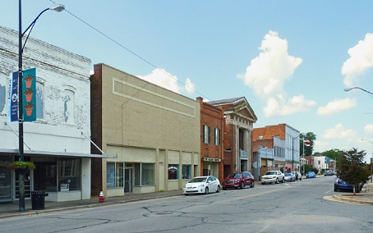
Residential Neighborhood | Can include both single family and multi-family units. Should encourage diverse housing styles and types to remain affordable to different groups | 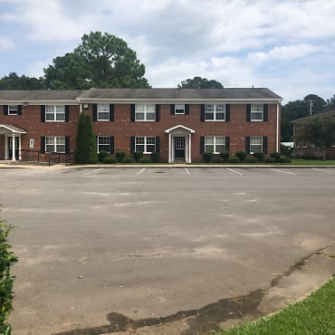
Medium Density Commercial | This can include low and medium density commercial activity, institutional, and medium residential. Should encourage businesses, restaurants, and mixed used, focused north of West Memorial Drive (Hwy 13) and north of the Atlantic District Fairground. | 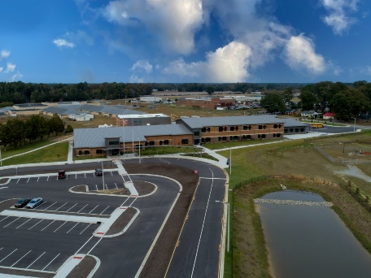
Rural Residential | Rural residential land can contain conservation and low-density housing. | 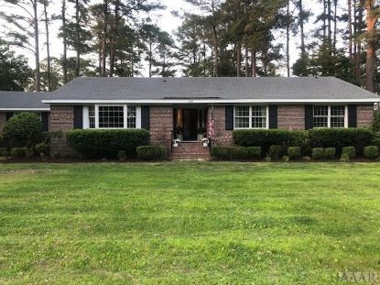
Conservation | The area near Ahoskie Creek and the eastern area not currently owned by the town should try to remain focused on natural resources and open space. Permitted activities can be preservation, athletic activities, solar, recreation, and green space. | 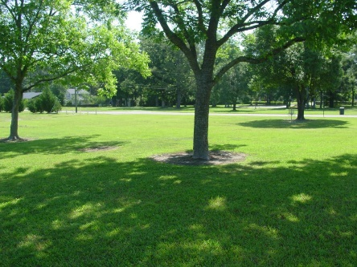

Future Land Use Map
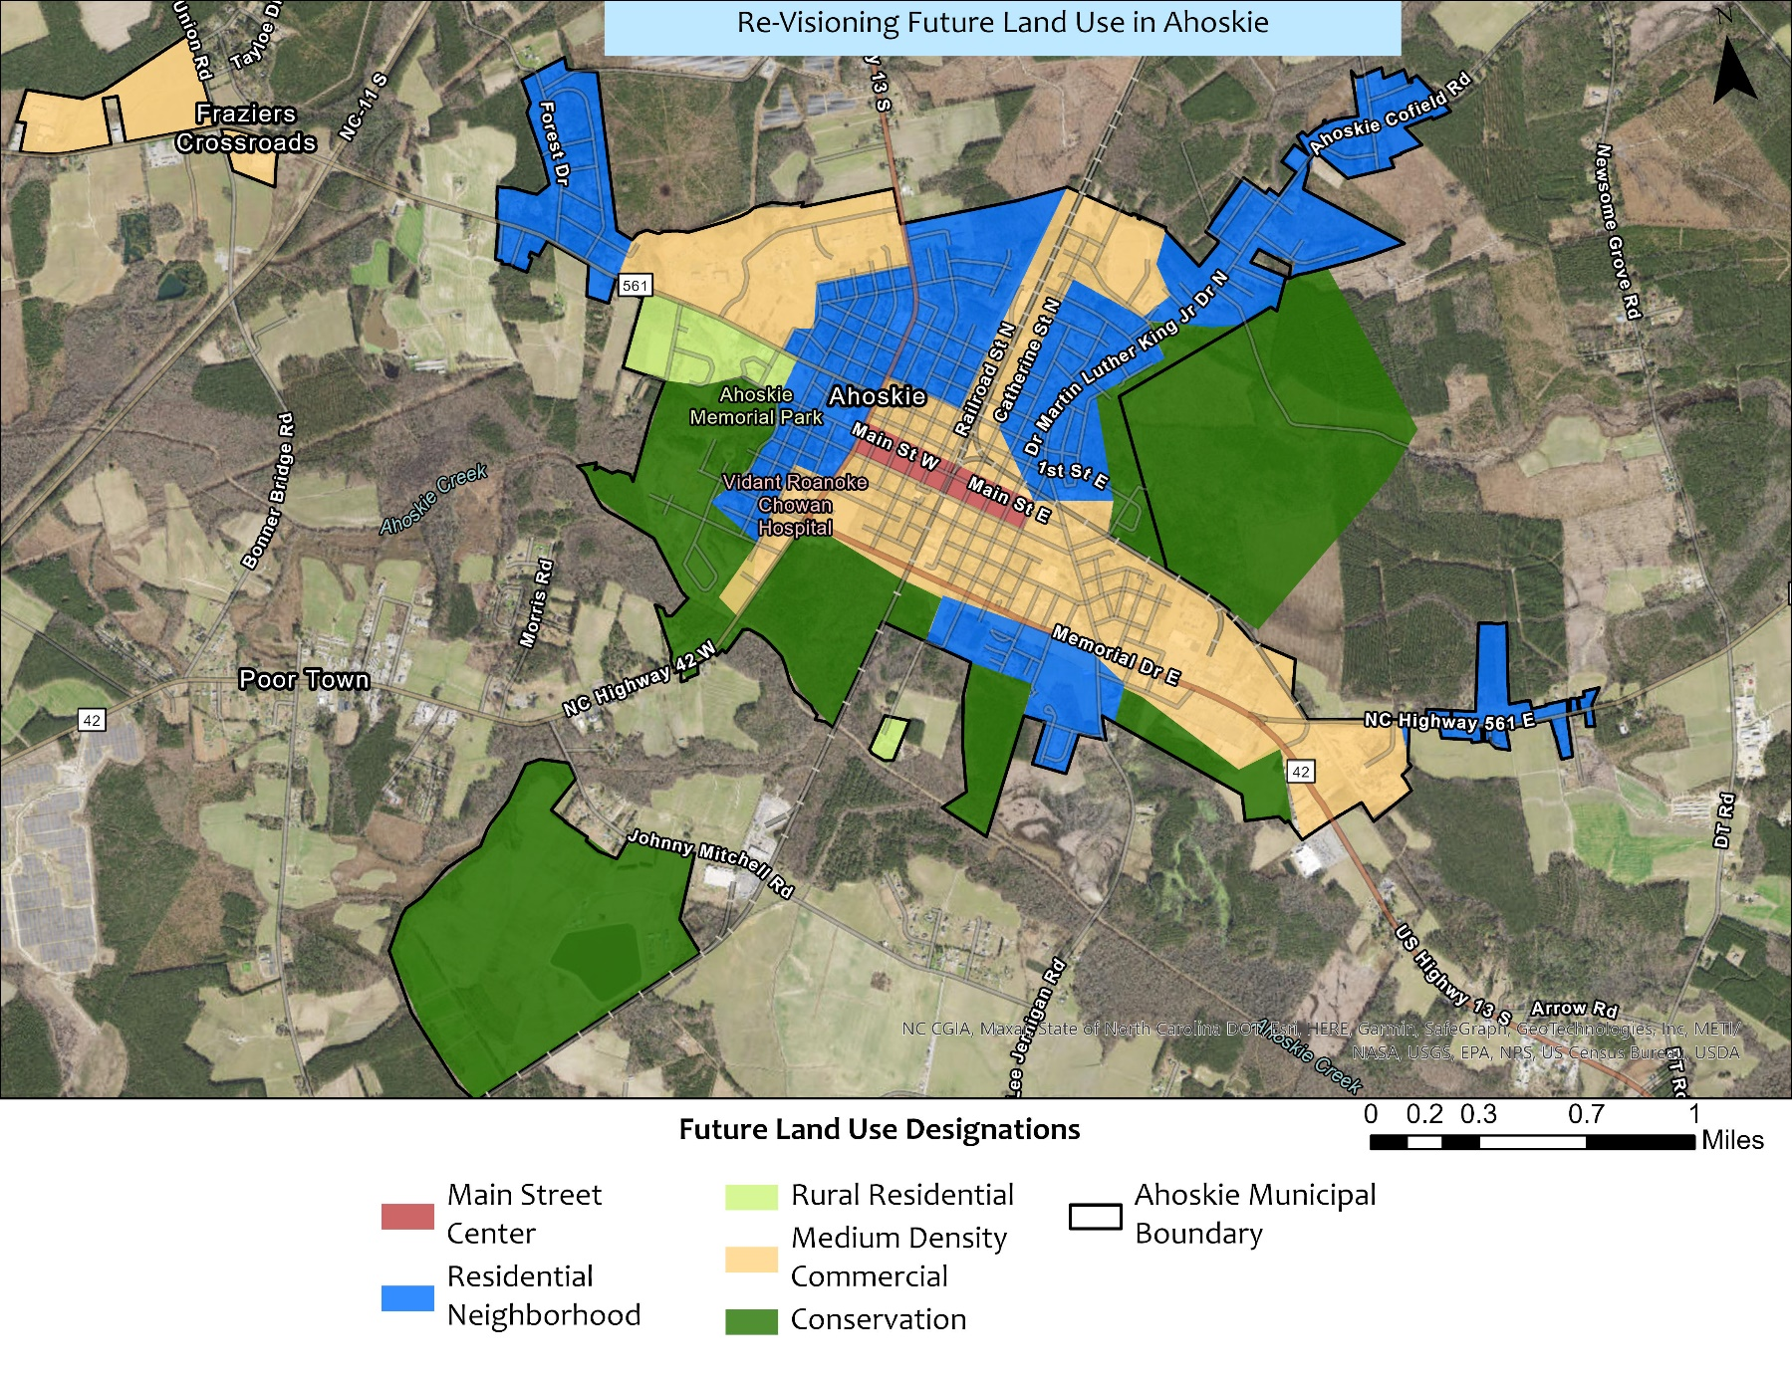

*This map represents potential future land use, not current land use or zoning.

Implementation Strategies
Implementation includes specific strategies that town leaders in Ahoskie can implement to accomplish the broader goals listed in the previous sections. These strategies are not just the sole responsibility of the town - effective strategies engage multiple partners and stakeholders to leverage community strengths. These strategies are grouped by goal but are listed in no order. Depending on the environment, funding, and partnerships at specific times, some strategies may be appropriate. The main purpose of this section is help Ahoskie realize its desired future goals listed in the goals and future land use map sections.
Implementation Strategy | Policy Addressed | Potential Outcomes | Potential Partners
Goal 1: Create a vibrant and welcoming downtown
Develop a public and private investment plan which aligns with residents’ needs | Encourage private investment | - Streamlined development process  - Increase coordination between public and private sector | Local developers
Seek input from the NC Main Street and the Rural Planning Center to learn more about opportunities for Main Street | Assess downtown for inclusion in the Main Street program and/or historic designation.  Assess historic designations for appropriateness & utility to the town | - Tourism opportunities  - Historic preservation | NC Department of Natural and Cultural Resources, Mainstreet Program, NC Rural Center, community-based officials, and others
Assess the needs of existing businesses, community assets, and current investments | Bolster community organizations capacity to support community needs | - Strength operations of community organizations to provide services for residents | Local business owners, town officials, and others
Goal 2: Increase affordable housing opportunities at all levels of income
Create a report evaluating housing cost burden for residents in Ahoskie | Address issues with housing cost burden and other issues for lower-income renters and homeowners. | - Increased understanding of the barriers to developing and renting affordable housing in Ahoskie. | Developers, town officials, community-based organizations, and others
Divert town funding toward lower-income and affordable housing assistance. | Address issues with housing cost burden and other issues for lower-income renters and homeowners. | - Creation of a fund to help housing affordability. This fund could provide loans, funds to improve housing, and others. | Developers, town officials, community-based organizations, and others
Investigate using Federal assistance funds such as the American Rescue Plan Act (ARPA) to help achieve community housing goals | Seek grant and tax credit opportunities for development activities. | - Allocate some ARPA funding to housing related community needs. | Developers, town officials, community-based organizations, and others
Investigate incentives for real estate developers | Encourage construction/remodeling for upscale housing | - Increased housing diversity and options that attract economic development to the area | Town officials, real estate developers
Implementation Strategy | Policy Addressed | Potential Outcomes | Potential Partners
Goal 3: Promote economic growth and development
Investigate using Federal assistance funds such as the American Rescue Plan Act (ARPA) and Small Business Association funding to help achieve community economic development goals | Strengthen small business economy | - Allocate some ARPA/SBA funding to economic development community needs. | Town officials, community-based organizations, and others
Recruit specific restaurants to the town | Encourage infill business | - Greater opportunity for residents’ choice and greater draw from outside town limits to popular restaurants | Town officials, restaurant managers
Create an economic development taskforce | Approach downtown revitalization as economic development strategy | - Taskforce could create new partnerships that help attract businesses specifically to Main Street area | Town officials, community-based organizations, local community colleges, and others
Goal 4: Create opportunities for community-wide enrichment
Investigate using Federal assistance funds such as the American Rescue Plan Act (ARPA) to help achieve community recreation goals | Provide recreational opportunities for all residents | - Allocate some ARPA funding to community recreation needs, such as trail systems, bike routes, river activities, parks, and indoor activities (movie theaters, bowling, etc.) | Town officials, community-based organizations, and others
Partner with youth-based organizations to investigate opportunities in Ahoskie | Create youth-focused programming | - Consider partnership with YMCA, Boys & Girls Club, or similar organizations to provide extracurricular activities for youth | Town officials, schools, community-based organizations, and others
Investigate using Federal assistance funds such as the American Rescue Plan Act (ARPA) to help achieve community broadband access goals | Increase broadband access | - Partner with the Mid-East Commission to coordinate broadband delivery efforts | Town officials, Mid-East Commission, utilities

Plan Adoption and Tracking
The Ahoskie Town Council are responsible for approving, implementing, and tracking plan progress. Once this plan is recommended by the Ahoskie Planning Board, it will be considered by the Ahoskie Town Council. After the public has had the opportunity to comment on the plan, it can be voted on by the council. Comprehensive plan adoption is necessary under the North Carolina General Statutes 160D.
After the plan is implemented, progress should be tracked. Tracking is important because it helps determine whether the goals outlined in this plan have been achieved, or if further policy interventions are needed. Tracking should be conducted on a. yearly basis. If the plan is not serving Ahoskie, it should be amended to reflect current needs and desires.

Hertford County Resilient Redevelopment Plan 2021- https://files.nc.gov/rebuildnc/documents/matthew/rebuildnc_hertford_plan_combined.pdf
Ahoskie CERRI 2021
https://www.ncrailways.org/railroads/north-carolina-a-virginia

